
Lab Assignment: 04
Course: Information Security
Submitted to: Mam Ambreen
Submitted by: Attiqa
Reg no: Sp24-bse-050

Task 1: Simple RSA Implementation (Without Libraries) Objective: Understand the math behind RSA Tasks: Write functions for:
- Manually implement key generation using small primes
•Encrypting a message (using public key)
- Decrypting a message (using private key)
- Test it on your name or a short string
CODE:
import random

def is_prime(n):
"""Simple primality test"""
if n < 2:
return False
for i in range(2, int(n**0.5) + 1):
if n % i == 0:
return False
return True

def generate_primes():
"""Generate two different small primes"""
primes = [p for p in range(50, 150) if is_prime(p)]
p = random.choice(primes)
q = random.choice(primes)

while p == q: # ensure p and q are different
q = random.choice(primes)

return p, q

def gcd(a, b):
"""Greatest Common Divisor"""
while b != 0:
a, b = b, a % b
return a

def mod_inverse(e, phi):
"""Find d where (d * e) % phi == 1"""
for d in range(2, phi):
if (d * e) % phi == 1:
return d
return None

def generate_keys():
"""Generate RSA keys manually"""

# 1. Choose two primes
p, q = generate_primes()
print(f"Primes chosen: p = {p}, q = {q}")

# 2. Compute n and φ(n)
n = p * q
phi = (p - 1) * (q - 1)
print(f"n = {n}, φ(n) = {phi}")

# 3. Choose e such that gcd(e, phi)=1
possible_e = [3, 5, 7, 11, 13, 17, 19]
e = random.choice(possible_e)

while gcd(e, phi) != 1:
e = random.choice(possible_e)

# 4. Compute d = modular inverse of e
d = mod_inverse(e, phi)

print(f"Public Key (e, n): ({e}, {n})")
print(f"Private Key (d, n): ({d}, {n})")

return (e, n), (d, n)

def encrypt(message, public_key):
"""Encrypt message using RSA"""
e, n = public_key
encrypted = []

for ch in message:
m = ord(ch) # convert to ASCII
c = pow(m, e, n) # m^e mod n
encrypted.append(c)

return encrypted

def decrypt(encrypted, private_key):
"""Decrypt RSA ciphertext"""
d, n = private_key
decrypted = ""

for c in encrypted:
m = pow(c, d, n) # c^d mod n
decrypted += chr(m) # back to character

return decrypted

# ===================== MAIN PROGRAM =====================

print("\n=== SIMPLE RSA DEMO ===\n")

# 1. Generate RSA keys
public_key, private_key = generate_keys()

# 2. Test on your name "ATTIQA"
print("\n--- Testing on Your Name ---")
name = "ATTIQA"
print(f"Original message: {name}")

encrypted = encrypt(name, public_key)
print("Encrypted:", encrypted)

decrypted = decrypt(encrypted, private_key)
print("Decrypted:", decrypted)

# Show RSA math for the first letter
print("\n--- RSA Math for first letter 'A' ---")
e, n = public_key
d, _ = private_key

m = ord('A')
c = pow(m, e, n)

print(f"A = ASCII {m}")
print(f"Encrypt: {m}^{e} mod {n} = {c}")
print(f"Decrypt: {c}^{d} mod {n} = {pow(c, d, n)}")

1. Overview
This Python program is a simple RSA encryption and decryption demo. It:
- Generates two prime numbers.
- Computes RSA keys (public and private keys).
- Encrypts a message (your name "ATTIQA").
- Decrypts the message back.
- Shows the RSA math for the first letter.
RSA is a widely used public-key cryptography system that uses two keys:
- Public key → used to encrypt.
- Private key → used to decrypt.

2. Functions in the code

a) is_prime(n)
- Checks if a number n is prime.
- A prime number has no divisors other than 1 and itself.
- Uses the simple method of checking all numbers from 2 to √n.
- Returns True if n is prime, otherwise False.

b) generate_primes()
- Creates a list of primes between 50 and 150.
- Randomly selects two different primes, p and q.
- These primes are used to calculate RSA keys.
Example: p = 53, q = 101

c) gcd(a, b)
- Computes Greatest Common Divisor (GCD) of a and b.
- Used to ensure that e (the public exponent) is coprime to φ(n).

d) mod_inverse(e, phi)
- Finds d such that:
[
(d \times e) \mod \phi = 1
]
- This is needed to calculate the private key.
- Uses a simple brute-force method to find d.

e) generate_keys()
- Generates the public key (e, n) and private key (d, n).
- Steps:
  - Choose two primes p and q.
  - Compute ( n = p \times q ) and ( \phi(n) = (p-1)(q-1) ).
    - n is used for both encryption and decryption.
  - Choose e (public exponent) such that gcd(e, φ(n)) = 1.
  - Compute d (private exponent) using modular inverse.
The public key is shared; the private key is kept secret.

f) encrypt(message, public_key)
- Encrypts a message using the public key (e, n).
- For each character ch in the message:
  - Convert to ASCII → m = ord(ch)
  - Encrypt using: ( c = m^e \mod n )
  - Append the ciphertext c to a list.
- Returns a list of encrypted numbers.

g) decrypt(encrypted, private_key)
- Decrypts the list of encrypted numbers using the private key (d, n).
- For each encrypted number c:
  - Decrypt using: ( m = c^d \mod n )
  - Convert back to character → chr(m)
  - Combine all characters to get the original message.

3. Main Program Steps
- Generate RSA keys
public_key, private_key = generate_keys()
- Random primes are chosen.
- n and φ(n) are calculated.
- e and d are selected.

- Encrypt your name "ATTIQA"
encrypted = encrypt(name, public_key)
- Each letter of "ATTIQA" is converted to a number and encrypted.
- Example: 'A' → 65 → encrypted number.

- Decrypt the message
decrypted = decrypt(encrypted, private_key)
- Converts the encrypted numbers back to letters.
- Result: "ATTIQA"

- RSA math for the first letter 'A'
m = ord('A') # 65
c = pow(m, e, n) # Encryption
pow(c, d, n) # Decryption
- Shows how 'A' is encrypted and decrypted mathematically.

4. Example Output
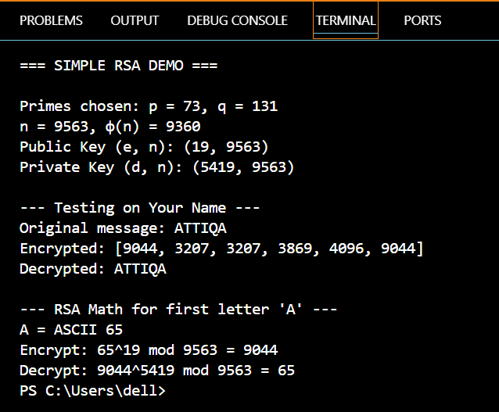
Task 2:
RSA with PyCryptodome Objective: Use real-world cryptographic libraries Tasks:
• Generate a 2048-bit key pair
• Encrypt and decrypt a user message
• Display results in hex
CODE:
# Import required libraries from PyCryptodome
from Crypto.PublicKey import RSA # For RSA key generation
from Crypto.Cipher import PKCS1_OAEP # For secure RSA encryption with padding
import binascii # For converting binary to hexadecimal

# Generate 2048-bit RSA key pair
# RSA.generate() creates both public and private keys
key = RSA.generate(2048) # 2048 bits = secure key size
public_key = key.publickey() # Extract public key (e, n)
private_key = key # Keep private key (d, n, p, q)

print("=== 2048-bit RSA Key Pair Generated ===")
print(f"Key Size: {key.size_in_bits()} bits") # Should show 2048

# Message to encrypt
message = "Hello, Attiqa!" # <-- Message changed here

# ENCRYPTION: Convert message to ciphertext using public key
cipher = PKCS1_OAEP.new(public_key) # Create cipher with OAEP padding
encrypted = cipher.encrypt(message.encode()) # Encrypt message (string → bytes)
hex_encrypted = binascii.hexlify(encrypted).decode() # Convert bytes to hex string

print(f"\nOriginal: '{message}'")
print(f"Encrypted (hex): {hex_encrypted[:50]}...") # Show first 50 hex chars

# DECRYPTION: Convert ciphertext back to message using private key
cipher = PKCS1_OAEP.new(private_key) # Create cipher with private key
decrypted = cipher.decrypt(encrypted).decode() # Decrypt and convert bytes → string

print(f"\nDecrypted: '{decrypted}'")
print(f"Success: {message == decrypted}") # Verify encryption/decryption worked

OUTPUT:
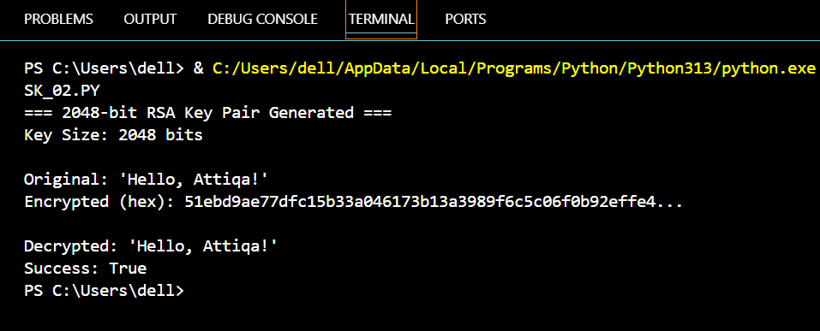
CODE EXPLANATION:

1. Purpose
This Python program demonstrates real-world RSA encryption and decryption using the PyCryptodome library.
- It generates a secure 2048-bit RSA key pair.
- Encrypts a message "Hello, Attiqa!" using the public key.
- Decrypts the ciphertext back to the original message using the private key.
- Displays the encrypted message in hexadecimal format for readability.

2. Code Breakdown

a) Import Libraries
from Crypto.PublicKey import RSA
from Crypto.Cipher import PKCS1_OAEP
import binascii
- RSA → For generating RSA key pairs.
- PKCS1_OAEP → Provides secure padding for RSA encryption/decryption.
- binascii → Converts encrypted bytes to a readable hexadecimal string.

b) Generate RSA Key Pair
key = RSA.generate(2048)
public_key = key.publickey()
private_key = key
- Generates a 2048-bit RSA key, which is considered secure.
- public_key is used for encryption.
- private_key is used for decryption and kept secret.

c) Set the Message
message = "Hello, Attiqa!"
- This is the message we want to encrypt.
- It is later converted to bytes for RSA encryption.

d) Encrypt the Message
cipher = PKCS1_OAEP.new(public_key)
encrypted = cipher.encrypt(message.encode())
hex_encrypted = binascii.hexlify(encrypted).decode()
- message.encode() converts the string into bytes.
- PKCS1_OAEP.new(public_key) creates a cipher object using the public key and OAEP padding.
- .encrypt() encrypts the message into ciphertext.
- binascii.hexlify() converts ciphertext bytes into hexadecimal format for easy display.

e) Decrypt the Message
cipher = PKCS1_OAEP.new(private_key)
decrypted = cipher.decrypt(encrypted).decode()
- PKCS1_OAEP.new(private_key) creates a cipher object using the private key.
- .decrypt() converts the ciphertext back into bytes.
- .decode() converts bytes back to the original string.

f) Verification
print(f"Success: {message == decrypted}")
- Checks if the decrypted message matches the original message.
- If True, the RSA encryption and decryption process worked correctly.

Task 3:
Create a Digital Signature Objective: Understand digital signatures Tasks:
• Generate RSA key pair
• Create a hash of a message (e.g., using SHA256)
• Sign the hash using private key
• Verify it using the public key
• Modify the message slightly and show that verification fails
CODE:
from Crypto.PublicKey import RSA
from Crypto.Signature import pkcs1_15
from Crypto.Hash import SHA256
import binascii

# Step 1: Generate RSA key pair
print("=== Step 1: Generate 2048-bit RSA Keys ===")
key = RSA.generate(2048)
private_key = key
public_key = key.publickey()
print(f"Key size: {key.size_in_bits()} bits")

# Step 2: Original message
original_msg = "Transfer $2000 to account Y"
print(f"\n=== Step 2: Original Message ===")
print(f"Message: '{original_msg}'")

# Step 3: Create digital signature
print(f"\n=== Step 3: Create Signature ===")
hash_obj = SHA256.new(original_msg.encode())
signer = pkcs1_15.new(private_key)
signature = signer.sign(hash_obj)
print(f"SHA256 hash: {hash_obj.hexdigest()}")
print(f"Signature (hex): {binascii.hexlify(signature).decode()[:50]}...")

# Step 4: Verify original signature (should succeed)
print(f"\n=== Step 4: Verify Original ===")
try:
verifier = pkcs1_15.new(public_key)
verifier.verify(SHA256.new(original_msg.encode()), signature)
print("✓ Signature VALID")
except:
print("✗ Signature INVALID")

# Step 5: Modify message and show verification fails
print(f"\n=== Step 5: Test with Modified Message ===")
modified_msg = "Transfer $5000 to account X"
print(f"Original: '{original_msg}'")
print(f"Modified: '{modified_msg}'")

try:
verifier = pkcs1_15.new(public_key)
verifier.verify(SHA256.new(modified_msg.encode()), signature)
print("✗ ERROR: Signature verified (should fail!)")
except:
print("✓ CORRECT: Signature verification failed")
print(" (Any change to message breaks the signature)")

OUTPUT OF CODE
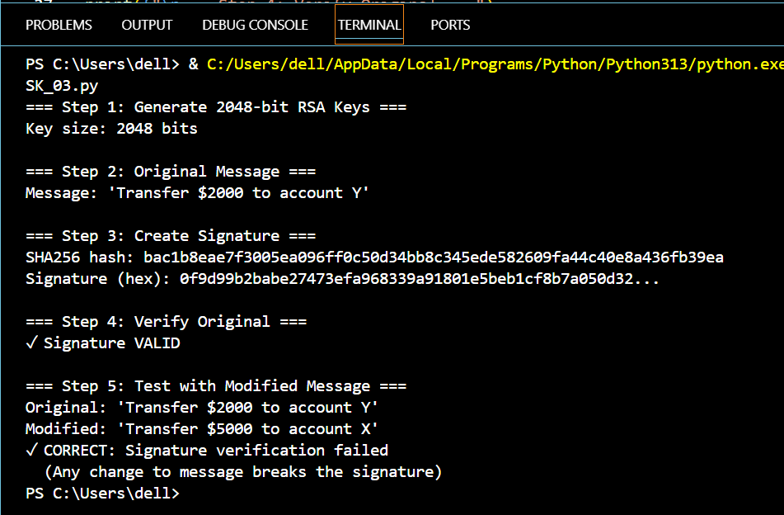

CODE EXPLANATION:

1. Purpose
This program demonstrates digital signatures using RSA and SHA-256.
- It generates a 2048-bit RSA key pair.
- Signs a message by creating a hash and encrypting it with the private key.
- Verifies the signature with the public key.
- Shows that any modification to the message invalidates the signature.

2. Step-by-Step Explanation

Step 1: Generate RSA Key Pair
key = RSA.generate(2048)
private_key = key
public_key = key.publickey()
- Creates a 2048-bit RSA private key.
- public_key is derived from the private key.

Step 2: Original Message
original_msg = "Transfer $1000 to account X"
- The message we want to sign.

Step 3: Create Digital Signature
hash_obj = SHA256.new(original_msg.encode())
signer = pkcs1_15.new(private_key)
signature = signer.sign(hash_obj)
- SHA256.new() → Computes the hash of the message.
- pkcs1_15.new(private_key) → Prepares private key for signing.
- .sign(hash_obj) → Creates the digital signature.
The signature uniquely represents the message and the sender.

Step 4: Verify Original Signature
verifier = pkcs1_15.new(public_key)
verifier.verify(SHA256.new(original_msg.encode()), signature)
- Uses the public key to verify the signature.
- If the message hasn’t been changed, verification succeeds.
- Output: ✓ Signature VALID

Step 5: Modify Message and Test Verification
modified_msg = "Transfer $5000 to account X"
verifier.verify(SHA256.new(modified_msg.encode()), signature)
- The message is slightly modified.
- Verification fails, showing that digital signatures detect tampering.
- Output: ✓ CORRECT: Signature verification failed

